Phoenix New Server – Installation Automation Instructions

Step 1: Launch PowerShell ISE as Administrator
- Click on the Start Menu.
- Search for PowerShell ISE.
- Right-click on Windows PowerShell ISE and select “Run as Administrator.”

Step 2: Open and Run Scripts in Sequence
Navigate to the Installation Automation Script folder and open each script in the following order:

1. All-in-One Pre-requisite Script
⚙️ Script Execution Prompts:
- Select drive for General Application Installation
- Select drive for Phoenix Application Installation
- Select drive for Machine Config Backup Path

Components Installed / Configured:
- FIPS Enabled
- Crystal Reports (32-bit and 64-bit)
- Phoenix Server Application
- Phoenix Client Application
- Adobe Reader 11
- .NET Hosting Bundle 8.0.4
- Microsoft Access Database Engine 2016
- Smart Inspect
- Microsoft Edge WebView2 Runtime
- Microsoft Report Viewer
- SQL Sys CLR Assemblies (32-bit and 64-bit)
- Microsoft OLE DB Driver
- Machine Config
- Page File Settings
- IIS Log Cleaner
  - Downloaded
  - Configured in Task Scheduler
- Firewall Ports
- Windows Update Settings
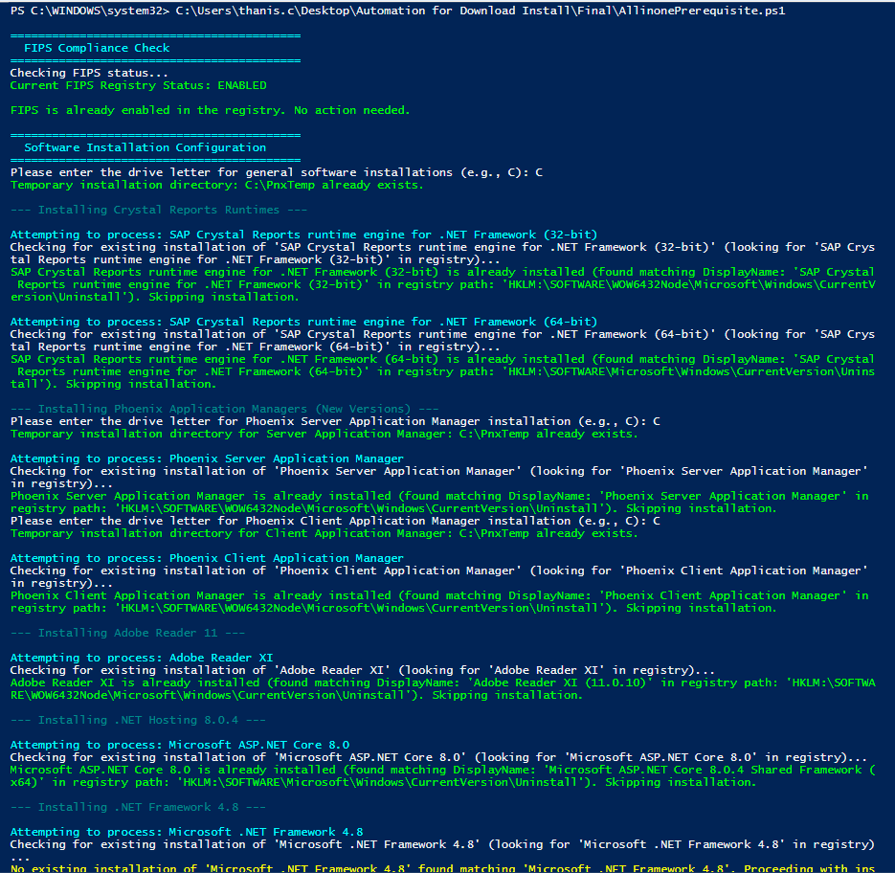

2. IIS Feature Enablement (If Not Already Enabled on the Server)
⚙️ Overview
If IIS (Internet Information Services) is not already installed on the server, it must be enabled using two dedicated scripts executed in sequence:

Script: IIS Config
- Perform pre-checks and environment setup before IIS installation.

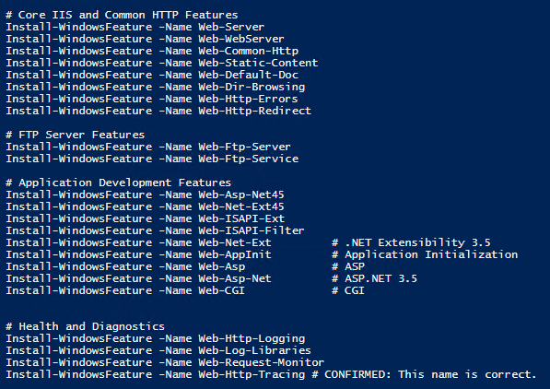

3. All in one Server Installation
⚙️ Required Configurations in the Batch Script
Ensure the following inputs are configured before executing the batch file:

- Configure Master DB Update Settings
- Specify the following parameters within the script:
  - SQL Instance Name
  - SQL Username & Password
  - FTP/SFTP Updater Settings for Server Application Manager

- Configure Required Applications & Instance Creation
- The script should be configured to:
  - Download and install all necessary applications from the list of pre-defined applications
  - Create application instances for required components based on the same pre-defined application
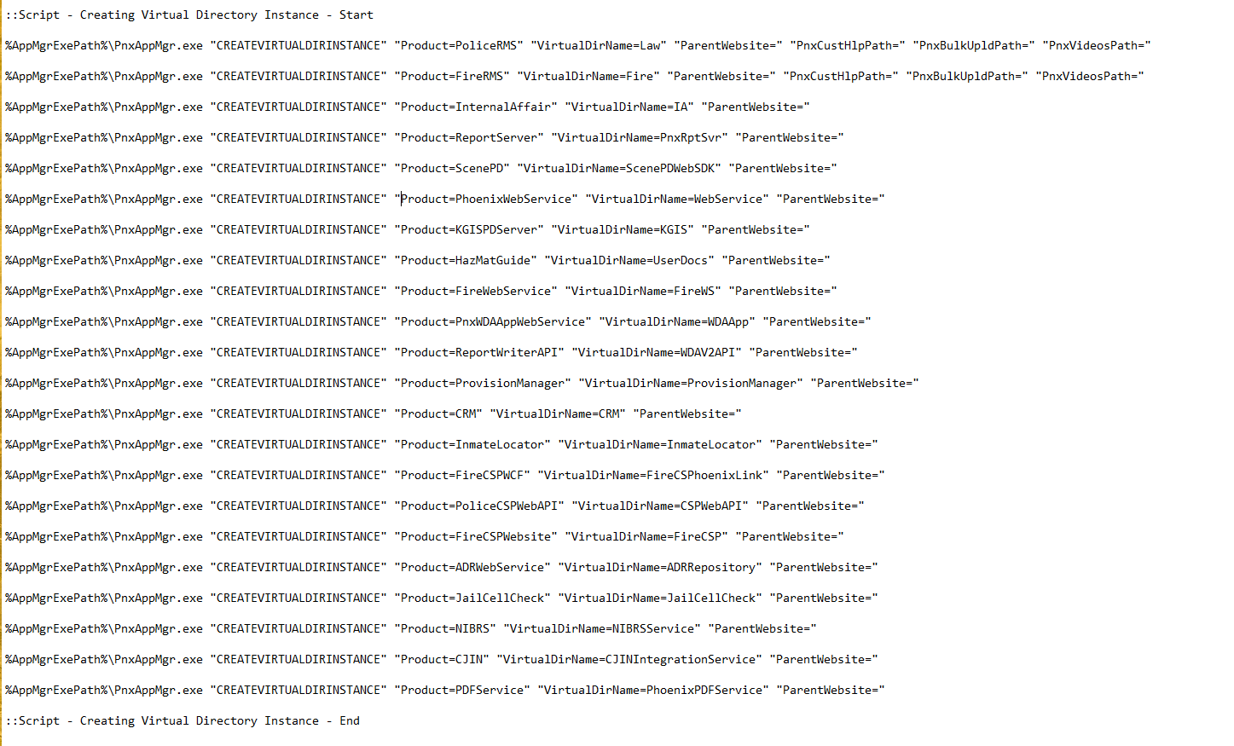
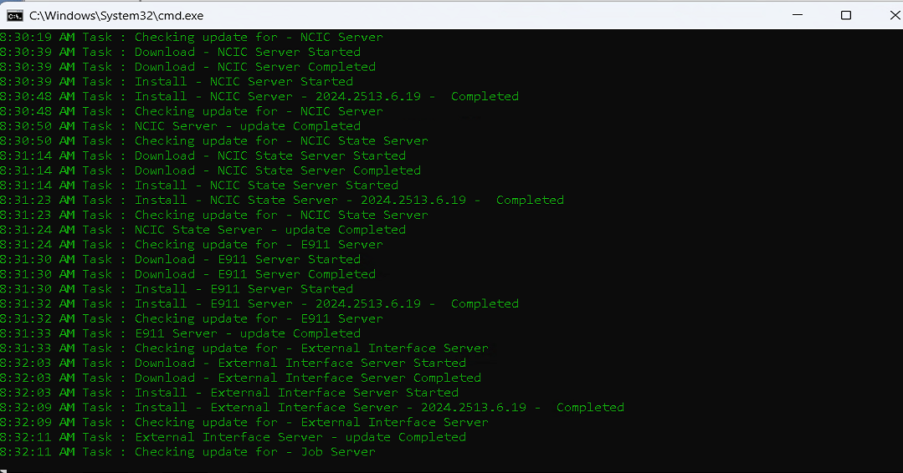
4. IIS App Pool Creation & Web Service Mapping
⚙️ Tasks to Perform in the Script
Ensure the batch or PowerShell script performs the following steps:

- Create Application Pools
- Create separate IIS Application Pools for each web-based service or application.

- Map Web Services to Respective App Pools
- Associate each web application or virtual directory with its corresponding IIS Application Pool.

- Windows Based Instance Configuration

  - Set Startup Type to Automatic
  - Set Recovery Failures > Restart the Service
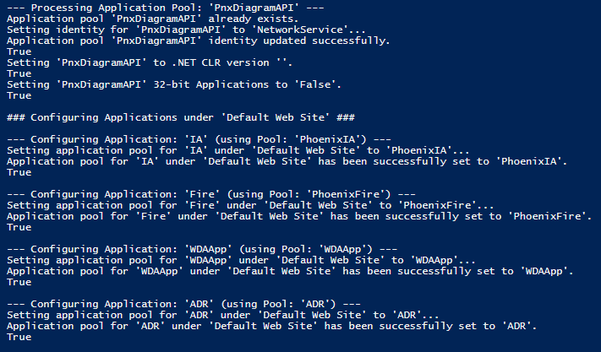

5. KPIDBList Database Creation
⚙️ Objective
Once the Provision manager Settings are completed, Create the Agency name and keep the DBConnStr from the Provision Manager to fill up the up-coming variables entries.
Automated:
- This Script will add the DBs Lists (Live, Training) required for a new server implementation.
- It will add the required Access URL Based on the User inputs
- It will Add the CADServer, CADPorts, NCICServer, NCICPorts in the Respective DBs.
Manual Works:

- Please refer the Last Steps.

Please follow the below Steps to set up the KPIDBList entries for Live and Training.
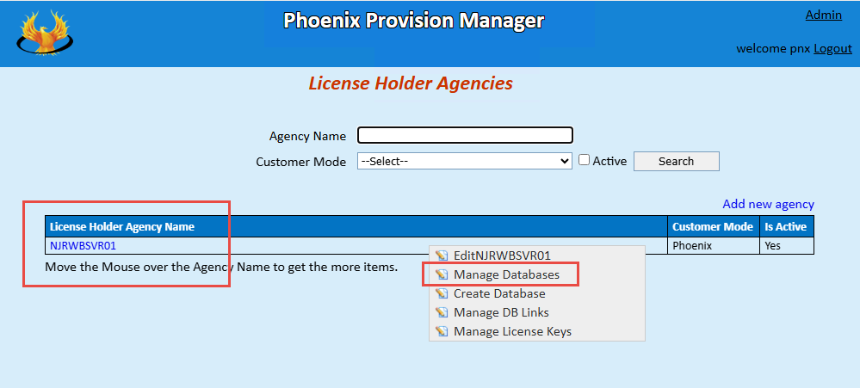

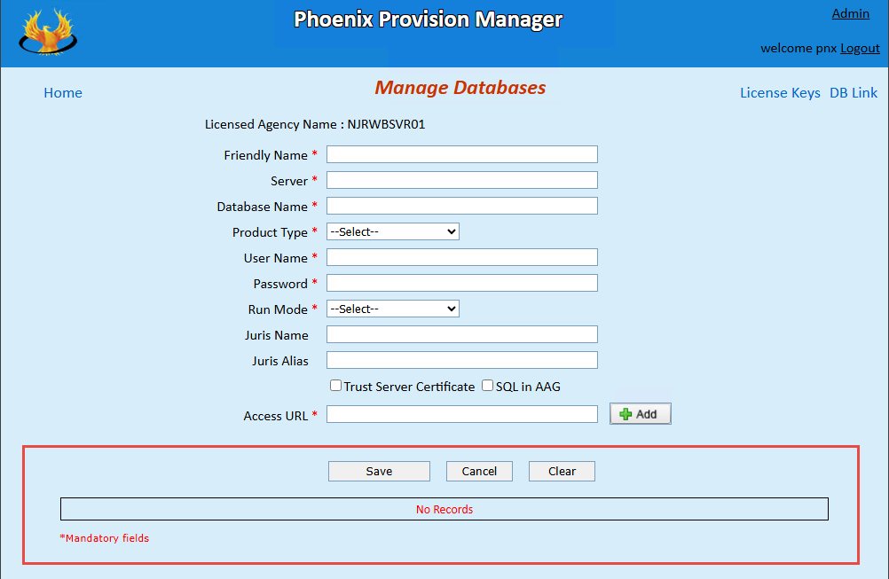

Fill up the Below marked entries to set up the KPIDBLists.
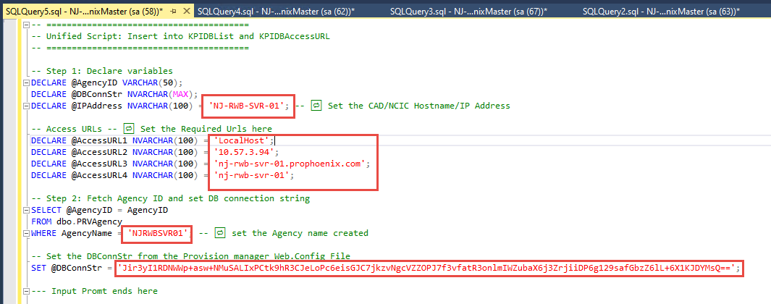

Input Prompt:
Step 1:
DECLARE @IPAddress NVARCHAR(100) = 'NJ-RWB-SVR-01'; -- 🔁 Set the CAD/NCIC Hostname/IP Address
Step 2:
-- Access URLs -- 🔁 Set the Required Urls here
DECLARE @AccessURL1 NVARCHAR(100) = 'LocalHost';
DECLARE @AccessURL2 NVARCHAR(100) = '10.57.3.94';
DECLARE @AccessURL3 NVARCHAR(100) = 'nj-rwb-svr-01.prophoenix.com';
DECLARE @AccessURL4 NVARCHAR(100) = 'nj-rwb-svr-01';
Step 3:
AgencyName = 'NJRWBSVR01'; -- 🔁 set the Agency name created
Step 4:
You can find the DBConnStr from the below screenshot:
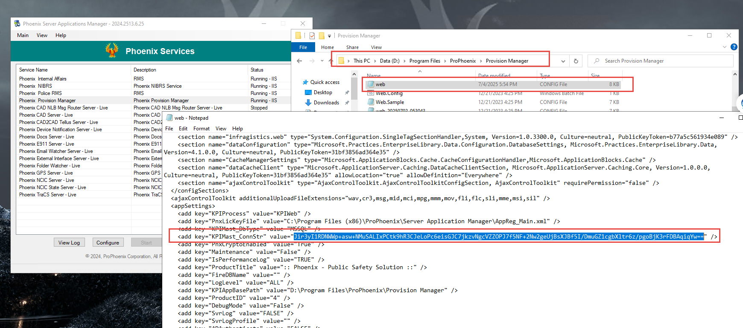
Kindly find the 5. KPIDBListScript notepad file and run the query in PhoenixMaster DB
After executing the scipt the DB would be configured as below:
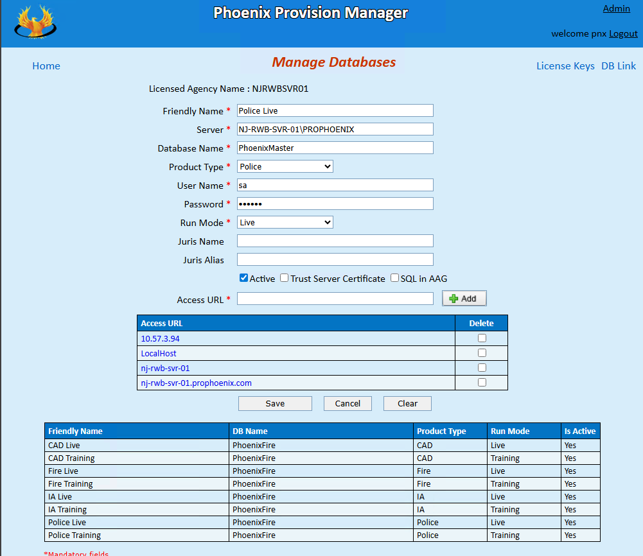

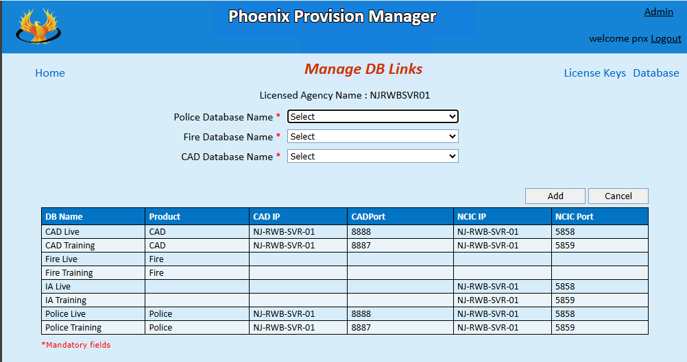

Manual Works:
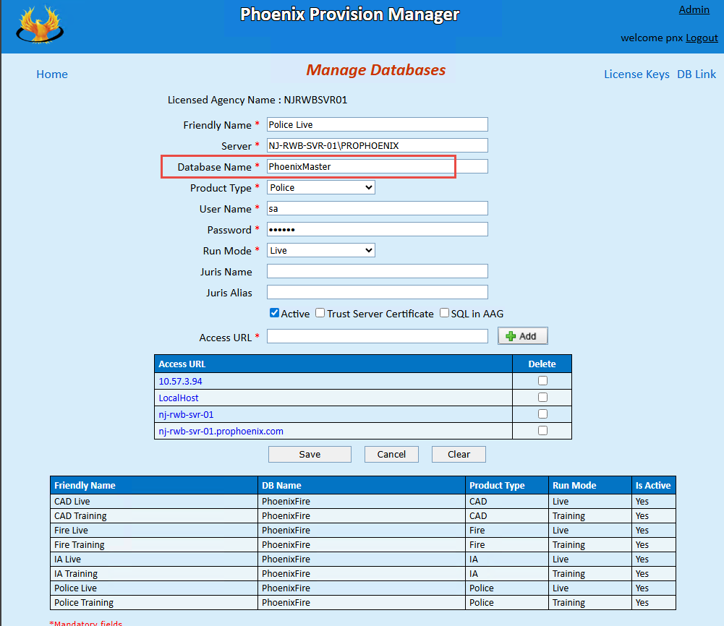

Step 1:
- We must change the DB Name for Each DB for the respective Database from the front end as we have copied the DBConnStr from the Provision manager.
- Save all the DBs after entering the Databases – This will encrypt the Connection Strings for all the Databases.
Step 2:
- You must perform the DB Link manually from the Manage DB Links sessions.
- Also Configure the Master Database Configuration in Server Application manager.
  - DB Name changes and CADVehlog Configurations.

6. SSRS Configuration Automation:
⚙️ Objective
To Automate the SQL Server Reporting Services (SSRS) and Report Server database Creation, with inputs provided during execution.

- Manual Inputs (Provided in Prompt)

- When running the configuration, the script/tool or manual process should prompt the user to enter the following:

Prompt Message | Expected Input Example
Enter SQL Server Name | SERVERNAME\INSTANCENAME or localhost
Enter SQL Username | sa or another valid SQL login
Enter SQL Password | ******** (user enters password)
Enter SSRS Version (v15/v16) | v15 → For versions below 2019  v16 → For 2020 and above
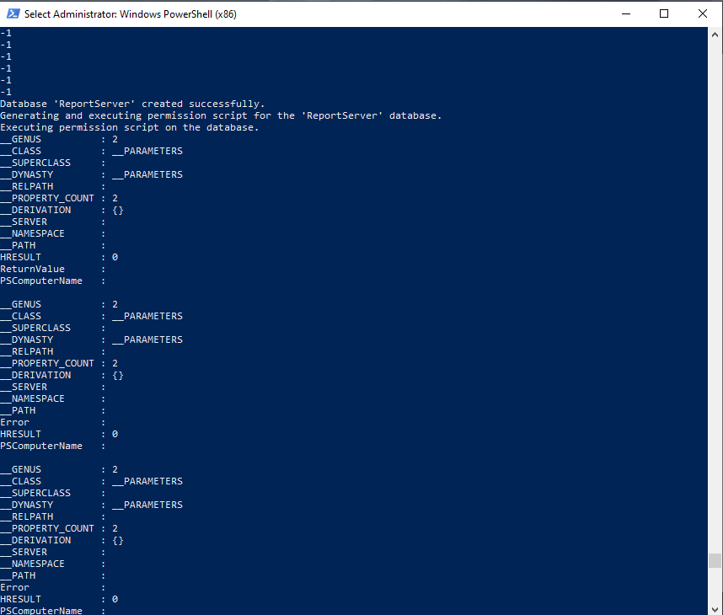
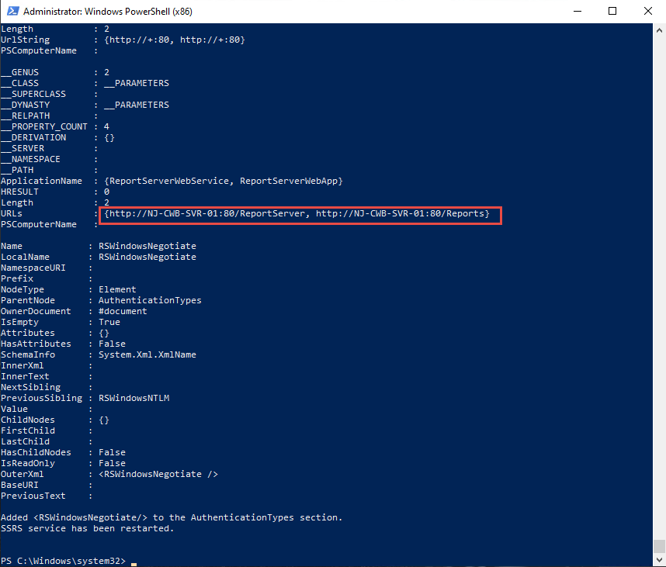
- After ran the script verify the URL of the Report server

6. Application Configuration script:
⚙️ Objective
To Automate the Application configuration by editing the Web config file through PowerShell script in a minute of time, previously it was taking about 30-40 mins of time.
- Manual Inputs (Provided in Prompt)
The Script will prompt for;
- Json File in which all the Keys and Values are savings with variables. (Enter the path of the 6.1appcongifsettings.json file )
- Report Server Username
- Report Server Domain
- Certificate name

This will search and fetch out the applications available in the system Drives and edit the Webconfig file for each product which needs to be configured.
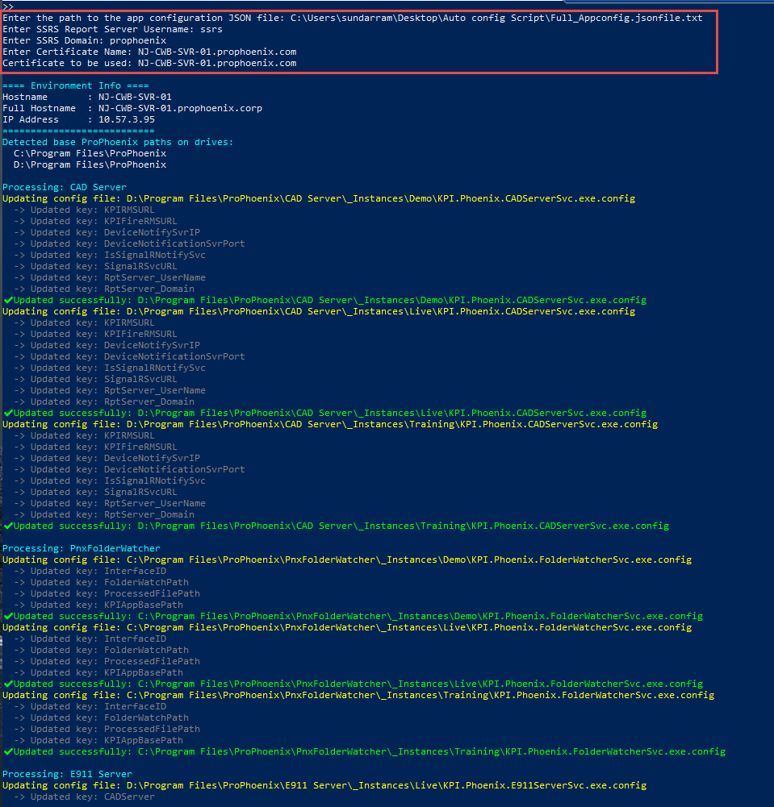

7. RMS Parameter Update
⚙️ Objective
To configure the Phoenix RMS using parameter files (Geo.txt and RMSParameter.txt) with environment-specific values. These files are referenced during execution of the RMS Parameter Update Script.

- Manual Input Preparation
Before running the RMS Parameter script, perform the following steps:
- Create Parameter Files
Prepare the following two text files with required values:

📄 7.1 Geo.txt
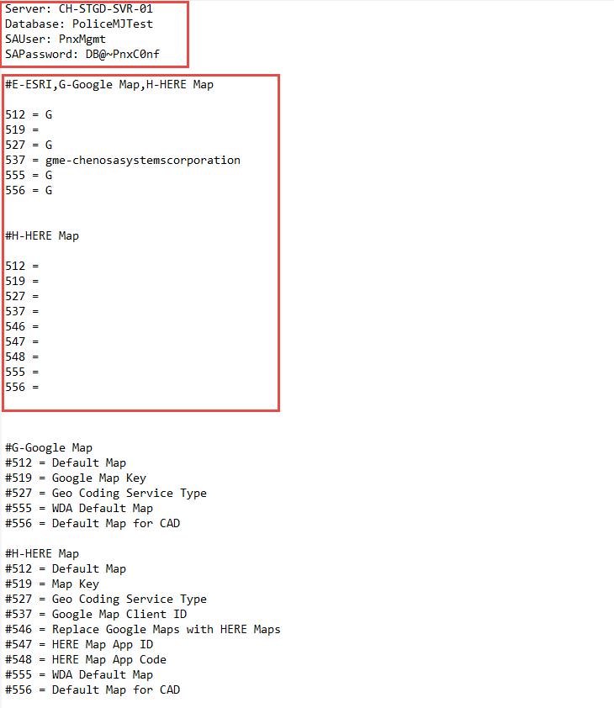

📄 7.3 RMSParameter.txt
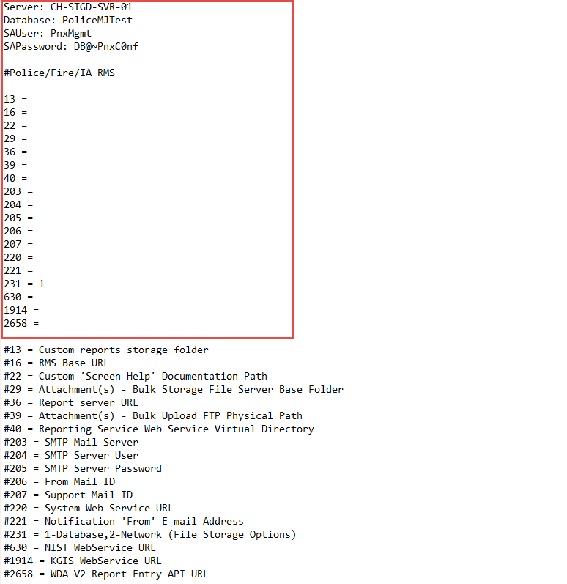

Place Geo.txt and RMSParameter.txt in a designated path accessible to the script

Screenshot for reference
